UNIT I

Micro and Macro Economics and its applications; Nature and scope of economics science; micro economics, Macro economics concept of equilibrium; Economic efficiency, Technical efficiency; Demand and Supply concepts; elasticity of demand and supply, Determination of demand, fixed cost, variable cost, average cost, marginal cost, opportunity cost; standard cost; concept of iso-quant; price of products, Break even analysis, Nature and functions of Money, National Income, GNP and savings, Inflation and deflation, Business cycles. Types and principles of management, Elements of Management; Planning, organizing, staffing, co- ordinating, etc Types of firm

## Economics:

Economics is the science that deals with the production and consumption of goods and services and the distribution and rendering of these for human welfare. The following are the economic goals;

* A high level of employment
* Price stability
* Efficiency
* An equitable distribution of income
* Growth

The field of economics is divided into two broad subfields: *macroeconomics* and

*microeconomics*.

## Macro Economics;

Macroeconomics is the study of aggregate economic behavior. Macroeconomists are concerned with such issues as national income, employment, inflation, national output, economic growth, interest rates, and international trade.

Macroeconomics is the study of entire economies and economic systems and specifically considers such broad economic aggregates as gross domestic product, economic growth, national income, employment, unemployment, inflation, and international trade. In general, the topics covered in macroeconomics are concerned with the economic environment within which firmmanagers operate. For the most part, macroeconomics focuses on the variables over which the managerial decision maker has little or no control but may be of considerable importance in the making of economic decisions at the micro level of the individual, firm, or industry.

## Micro Economics;

Microeconomics is the study of individual economic behavior. Micro economists are concerned with output and input markets, product pricing, input utilization, production costs, market structure, capital budgeting, profit maximization, production technology, and so on.

By contrast, microeconomics is the study of the behavior and interaction of individual economic agents. These economic agents represent individual firms, consumers, and governments. Microeconomics deals with such topics as profit maximization, utility maximization, revenue or sales maximization, *production efficiency*, market structure, capital budgeting, environmental protection, and governmental regulation.

## CONCEPT OF ENGINEERING ECONOMICS

Science is a field of study where the basic principles of different physical systems are formulated and tested. Engineering is the application of science. It establishes varied applications systems based on different scientific principles.

It is clear that price has a major role in deciding the demand and supply of the product. Hence from the organizations point of view, efficient and effective functioning of the organization would certainly help it to provide goods/services at a lowe cost which in turn will enable it to fix a lower price for its goods or services.

The following discusses the different types of efficiency and their impact on the operation of businesses and the definition and scope of engineering economics.

## Types of Efficiency

Efficiency of a system is generally defined as the ratio of its output to input. The efficiency can be classified into technical efficiency and economic efficiency.

## Technical Efficiency

It is the ratio of the output to input of a physical system. The physical system may be a diesel engine, a machine working in a shop floor, furnance etc,



The technical efficiency of a diesel engine is as follows

In practice technical efficiency can never be more than 100% . This is mainly due to frictional loss and incomplete combustion of fuel, which are considered to be unavoiadable phenomena in the working of a diesel engine.

## Economic efficiency

Economic efficiency is the ratio of output to input of a business system.



Worth is the annual revenue generated by way of operating the business and cost is the total annual expenses incurred in carrying out the business. For the survival and growth of any business the economic efficiency should be more than 100%.

Economic efficiency is also called productivity. There are several wazs of improving productivity.

* Increased output for the same input
* Decreased output for the same output
* By a proporionate increase in the output which is more than the proportionate increase in the input
* By a proportionate decrease in the input which is more than the proportionate decrease in the output
* Through simultaneous increase in the output with decrease in the input.

*Increased output for the same input.* In this strategy, the output is increased while keeping the input constant. Let us assume that in a steel plant, the layout of the existing facilities is not proper. By, slightly altering the location of the billet-making section., and bringing it closer to the furance which produces hot metal , the scale formation at the top of ladles will be considerably reduced. The molten metal is usually carried in ladles to the billet-making section. In the lng run, this would give more yield in terms of tonnes of billet produced. In this exercise, there is no extra cost involved. The only task is the relocation of the billet-making facility wich involves an insignficant cost.

*Decreased input for the same out put.* In this strategy, the input is decreased to produce the same output . let us assume that there exists a substitue raw material to manfacture a product and it is available at a lower price. If we can identify such a material and use it for manfacturing the product then certainly it will reduce the input. In this excerise, the job of the purchase department is to identify an alternate subsitute material. The process of identification does not involve any extra cost. So, the productivity ratio will increase because of the decreased input by way of using cheaper raw materials to produce the same output.

*Less proportionate increase in output is more than that of the input.* consider the example of introducing a new product into the existing product mix of an organization. Let us assume that the existing facilities are not fully utilized an the R&D wing of the company has identified a new product which has a very good market and which can be manfactured with the surplus facilities of the organization. If the new product is taken up for production, it will lead to

* An increase in the revenus of the organiyation by way of selling the new product in addition to the existing product mix and
* An increase in the material cost and operation and maintenance cost of machineries because of producing the new product.

If we examine these these two increase closely, the proportionate increase in the revenue will be more than the proprotionate increase in the input cost. Hence, there will be a net increase in the productivity ratio.

*When proprotionate decrease in input is more than that of the output.*let us consider the converse of the pervious example, i.e dropping an uneconomical product from the existing product mix. This will result in the following:

* A decrease in the revenue of the organization
* A decrease in the material cost, and operation and maintenance cost of machinery

If we closely examine these two decreases, we will se that the proportionate decrease in the input cost will more than the proportionate decrease in the revenue. Hence, there will be net increase in the productivity ratio.

*Simultaneous increase in output and decrease in input.* let us asume that there are advanced automated technologies like robots and automated guided vechile system (AGVS, available in the market which can be empolyed in the organization we are interested in. If we employ these modern tools, then:

* There will be drastic reduction in the operation cost, initiallly, the cost on equipment would be very high. But in the long run, the reduction in the operation cost would break- even the high intial investment and offer more savings on the input.
* These advanced facilities would help in producing more products because they do not experience fatigue. The increased production will yield more revenue.
* In this example in the long run, there is an increase in the revenue and a decrease in the input. hence, the productivity ratio will increase at a faster rate.

## Definition and scope of engineering economics

As stated earlier, efficient functioning of any business organization would enable it to provide goods/services at a lower price. In the process of managing organizations, the managers at different levels should take appropriate economic decisions which will help in minimizing investment, operating and maintenance expenditures besides increasing the revenue, savings and other related gains of the organization.

## Definition

Engineering economics deals with the methods that enable one to take economic decisions towards minimizing costs and /or maximizing benefits to business organizations.

## Scope

The issues that covered in this book are elementary economic analysis, intrest formulae, bases for comparing alternatives, present worth method, future worth method, annual equilant method, rate of return method, replacement analysis, depreciation, evaluation of public alternatives, inflation adjusted investment decisions, make or buy decisions, inventory control, project management, value engineering and linear programming

## CIRCULAR FLOW OF ECONOMIC ACTIVITY

The individuals own or control resources which are necessary inputs for the firms in the production process. These resources (factors of production) are classified into four types.

**Land:** It includes all natural resources on the earth and below the earth. Non renewable resources such as oil, coal etc once used will never be replaced. It will not be available for our children. Renewable resources can be used and replaced and is not depleted with use.

**Labor:** is the work force of an economy. The value of the worker is called as human capital. **Capital:** It is classified as working capital and fixed capital (not transformed into final products) **Entrepreneurship:** It refers to the individuals who organize production and take risks.

All these resources are allocated in an effective manner to achieve the objectives of consumers (to maximize satisfaction), workers (to maximize wages), firms (to maximize the output and profit) and government (to maximize the welfare of the society).

The fundamental economic activities between households and firms are shown in the diagram. The circular flows of economic activities are explained in a clockwise and counterclockwise flow of goods and services.

The four sectors namely households, business, government and the rest of the world can also be considered to see the flow of economic activities. The circular flow of activity is a chain in which production creates income, income generates spending and spending in turn induces production.

The major four sectors of the economy are engaged in three economic activities of

production, consumption and exchange of goods and services. These sectors are as follows:

**Households:** Households fulfill their needs and wants through purchase of goods and services from the firms. They are owners and suppliers of factors of production and in turn they receive income in the form of rent, wages and interest.

**Firms:** Firms employ the input factors to produce various goods and services and make payments to the households.

**Government:** The government purchases goods and services from firms and also factors of production from households by making payments.

**Foreign sector:** Households, firms and government of India purchase goods and services (import) from abroad and make payments. On the other hand all these sectors sell goods and services to various countries (export) and in turn receive payments from abroad

## Chart - 1

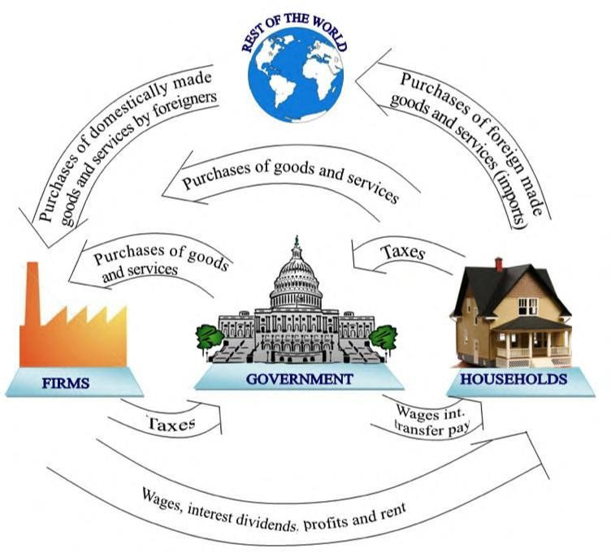

**Circular Flow Of Economic Activity**

7

The above said four agents take economic decisions to produce goods and services and to exchange them and to consume them for satisfying the wants of the economy as a whole. Understanding the opportunities and constraints in the exchange is essential to take better decision in business. This is discussed in the forthcoming chapters in detail.

The economy comprises of the interaction of households, firms, government and other nations. Households own resources and supply factor services like land, raw material, labour and capital to the firms which helps them to produce goods and services. and

In turn, firms pay rent for land, wages for their labour interest against the capital invested by the households. The earnings of the household are used to purchase goods and services from the firms to fulfill their needs and wants, the remaining is saved and it goes to the capital market and is converted as investments in various businesses.

The household and business firms have to pay taxes to the government for enjoying the services provided. On the other hand firms and households purchase goods and services (import) from various countries of the world. Firms tend to sell their products to the foreign customers (export) who earn income for the firm and foreign exchange for the country.

Therefore, it is clear that households supply input factors, which flow to firms. Goods and services produced by firms flow to households

## Flow in an Economy;

The flow of goods, services, resources and money payments in a simple economy are shown in below diagram. Households and business are the two major entities in a simple economy. Business organizations use various economics resources like land, labour and capital which will be used by them. Business organizations make payment of money to the households for

receiving various resources. The households in turn make payment of money to business organization for receiving consumer goods and services. This cycle shows the interdependence between the two major entities in a simple economy

Money payments for consumer goods and services

Consumer goods, Services

Business



Provide goods and services to consumers.

Use resources, inputs provided by households



Households

Consume final goods and services produced by business and services

Provide productive inputs to businesses

Money payments for resources, rents, wages, salaries, interest and profit

## Law of supply and Demand

An interesting aspect of the economy is that the demand and supply of a product are interdependent and they are sensitive with the respect to the price of that product. The interrelationships between them are shown in above diagram.

And also it is clear that when there is a decrease in the price of a product, the demand for product increases and its supply decreases. Also, the product is more in demand for the product increases. At the same time, lowering of the price of the product makes the producers restrain from releasing more quantities of the product in the market. Hence the supply of the product is

decreased. The point of intersection of the supply curve and the demand curve is known as the equilibrium point. At the price corresponding to this point, the quantity of supply is equal to the quantity of demand. Hence this point is called equilibrium point.

Economics Resources; Land, Labour,Capital

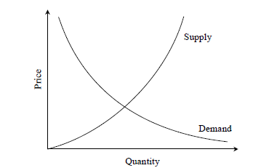

## Factors influencing demand

The shape of the demand curve is influenced by the following factors;

* Income of the people
* Prices of related goods
* Tastes of consumers

If the income level of the people increases significantly, then their purchasing power will naturally improve. This would definitely shift the demand curve to the north east direction. A converse situation will shift the demand curve to the south west direction.

If, for instance the price of television sets is lowered drastically its demand would naturally go up. As a result, the demand for its associated product, namely VCDs, would also increase. Hence the prices of related foods influence the demand of products.

Over a period of time, the preferences of the people for a particular product may increase, which in turn, will affect the demand. For instance diabetic people prefer to have sugar free products. If the incidence of diabetes rises naturally there will be increased demand for sugar free products.

## Factors influencing supply

The shape of the supply curve is affected by the following factors:

* + - 1. Cost of the inputs 2) Technology 3) Weather 4) Prices of related goods

If the cost of inputs increases, then naturally, the cost of the product will go up. In such a situation, at the prevailing price of the product the profit margin per unit will be less. The producers will then reduce the production quantity, which in turn will affect the supply of the product. For instance if the prices of fertilizers and cost of labor are increased significantly in agriculture the profit margin per bag of paddy will be reduced. So, the farmers will reduce the area of cultivation, and hence the quantity of supply of paddy will be reduced at the prevailing prices of the paddy.

If there is advancement in technology used in manufacture of the product in the long run, there will be a reduction in the production cost per unit. This will enable the manufacturer to have a greater profit margin per unit at the prevailing price of the product. Hence, the producer will be tempted to supply more quantity to the market.

Weather also has a direct bearing on the supply of products. For example demand for woolen products will increase during winter. This means the prices of woolen goods will be increased in winter. So, naturally, manufacturers will supply more volume of woolen goods during winter.

Again take the case of television sets. If the price of TV sets is lowered significantly then its demand would naturally go up. As a result, the demand for associated products like VCDs would also go up. Over a period of time, this will lead to an increase in the price of VCDs, which would result in more supply of VCD’s

## DETERMINANTS OF DEMAND:

There are various factors affecting the demand for a commodity. They are:

1. **Price of the good:** The price of a commodity is an important determinant of demand. Price and demand are inversely related. Higher the price less is the demand and vice versa.
2. **Price of related goods:** The price of related goods like substitutes and complementary goods also affect the demand. In the case of substitutes, rise in price of one commodity lead to increase in demand for its substitute. In the case of complementary goods, fall in the price of one commodity lead to rise in demand for both the goods.
3. **Consumer’s Income:** This is directly related to demand. A change in the income of the

consumer significantly influences his demand for most commodities. If the disposable income increases, demand will be more.

1. **Taste, preference, fashions and habits:** These are very effective factors affecting demand for a commodity. When there is a change in taste, habits or preferences of the consumer, his demand will change. Fashions and customs in society determine many of our demands.
2. **Population:** If the size of the population is more, demand for goods will be more . The market demand for a commodity substantially changes when there is change in the total population.
3. **Money Circulation:** More the money in circulation, higher the demand and vice versa.
4. **Value of money:** The value of money determines the demand for a commodity in the market. When there is a rise or fall in the value of money there may be changes in the relative prices of different goods and their demand.
5. **Weather Condition:** Weather is also an important factor that determines the demand for certain goods.
6. **Advertisement and Salesmanship:** If the advertisement is very attractive for a commodity, demand will be more. Similarly if the salesmanship and publicity is effective then the demand for the commodity will be more.
7. **Consumer’s future price expectation:** If the consumers expect that there will be a rise in prices in future, he may buy more at the present price and so his demand increases.
8. **Government policy (taxation):** High taxes will increase the price and reduce demand, while low taxes will reduce the price and extend the demand.
9. **Credit facilities:** Depending on the availability of credit facilities the demand for commodities will change. More the facilities higher the demand.
10. **Multiplicity of uses of goods:** if the commodity has multiple uses then the demand will be more than if the commodity is used for a single purpose.

## DEMAND DISTINCTIONS: TYPES OF DEMAND

Demand may be defined as the quantity of goods or services desired by an individual, backed by the ability and willingness to pay.

1. **Direct and indirect demand: (or) Producers’ goods and consumers’ goods:** demand for goods that are directly used for consumption by the ultimate consumer is known as direct demand (example: Demand for T shirts). On the other hand demand for goods that are used by producers for producing goods and services. (example: Demand for cotton by a textile mill)
2. **Derived demand and autonomous demand:** when a produce derives its usage from the use of some primary product it is known as derived demand. (example: demand for tyres derived from demand for car) Autonomous demand is the demand for a product that can be independently used. (example: demand for a washing machine)
3. **Durable and non durable goods demand:** durable goods are those that can be used more than once, over a period of time (example: Microwave oven) Non durable goods can be used only once (example: Band-aid)
4. **Firm and industry demand:** firm demand is the demand for the product of a particular firm. (example: Dove soap) The demand for the product of a particular industry is industry demand (example: demand for steel in India )
5. **Total market and market segment demand:** a particular segment of the markets demand is called as segment demand (example: demand for laptops by engineering students) the sum total of the demand for laptops by various segments in India is the total market demand. (example: demand for laptops in India)
6. **Short run and long run demand:** short run demand refers to demand with its immediate reaction to price changes and income fluctuations. Long run demand is that which will ultimately exist as a result of the changes in pricing, promotion or product improvement after market adjustment with sufficient time.
7. **Joint demand and Composite demand:** when two goods are demanded in conjunction with one another at the same time to satisfy a single want, it is called as joint or complementary demand. (example: demand for petrol and two wheelers) A composite demand is one in which a good is wanted for several different uses. ( example: demand for iron rods for various purposes)
8. **Price demand, income demand and cross demand:** demand for commodities by the consumers at alternative prices are called as price demand. Quantity demanded by the consumers at alternative levels of income is income demand. Cross demand refers to the quantity demanded of commodity ‘X’ at a price of a related commodity ‘Y’ which may be a substitute or complementary to X.

**Price Demand:** The ability and willingness to buy specific quantities of a good at the prevailing price in a given time period.

**Income Demand:** The ability and willingness to buy a commodity at the available income in a given period of time.

**Market Demand:** The total quantity of a good or service that people are willing and able to buy at prevailing prices in a given time period. It is the sum of individual demands.

**Cross Demand:** The ability and willingness to buy a commodity or service at the prevailing price of the related commodity i.e. substitutes or complementary products. For example, people buy more of wheat when the price of rice increases.

## EXCEPTIONAL DEMAND CURVE:

The demand curve slopes from left to right upward if despite the increase in price of the commodity, people tend to buy more due to reasons like fear of shortages or it may be an absolutely essential good.

The law of demand does not apply in every case and situation. The circumstances when the law of demand becomes ineffective are known as exceptions of the law. Some of these important exceptions are as under

## Giffen Goods:

Some special varieties of inferior goods are termed as Giffen goods. Cheaper varieties millets like bajra, cheaper vegetables like potato etc come under this category. Sir Robert Giffen of Ireland first observed that people used to spend more of their income on inferior goods like potato and less of their income on meat. After purchasing potato the staple food, they did not have staple food potato surplus to buy meat. So the rise in price of potato compelled people to buy more potato and thus raised the demand for potato. This is against the law of demand. This is also known as Giffen paradox.

## Conspicuous Consumption / Veblen Effect:

This exception to the law of demand is associated with the doctrine propounded by Thorsten Veblen. A few goods like diamonds etc are purchased by the rich and wealthy sections of society. The prices of these goods are so high that they are beyond the reach of the common man. The higher the price of the diamond, the higher its prestige value. So when price of these goods falls, the consumers think that the prestige value of these goods comes down. So quantity demanded of these goods falls with fall in their price. So the law of demand does not hold good here.

## Conspicuous Necessities:

Certain things become the necessities of modern life. So we have to purchase them despite their high price. The demand for T.V. sets, automobiles and refrigerators etc. has not gone down in spite of the increase in their price. These things have become the symbol of status. So they are purchased despite their rising price.

## Ignorance:

A consumer’s ignorance is another factor that at times induces him to purchase more of the commodity at a higher price. This is especially true, when the consumer believes that a high- priced and branded commodity is better in quality than a low-priced one.

## Emergencies:

During emergencies like war, famine etc, households behave in an abnormal way. Households accentuate scarcities and induce further price rise by making increased purchases even at higher prices because of the apprehension that they may not be available. . On the other hand during depression, , fall in prices is not a sufficient condition for consumers to demand

more if they are needed.

## Future Changes In Prices:

Households also act as speculators. When the prices are rising households tend to purchase large quantities of the commodity out of the apprehension that prices may still go up. When prices are expected to fall further, they wait to buy goods in future at still lower prices. So quantity demanded falls when prices are falling.

## Change In Fashion:

A change in fashion and tastes affects the market for a commodity. When a digital camera replaces a normal manual camera, no amount of reduction in the price of the latter is sufficient to clear the stocks. Digital cameras on the other hand, will have more customers even though its price may be going up. The law of demand becomes ineffective.

## Demonstration Effect:

It refers to a tendency of low income groups to imitate the consumption pattern of high income groups. They will buy a commodity to imitate the consumption of their neighbors even if they do not have the purchasing power.

## Snob Effect:

Some buyers have a desire to own unusual or unique products to show that they are different from others. In this situation even when the price rises the demand for the commodity will be more.

## Speculative Goods/ Outdated Goods:

Speculative goods such as shares do not follow the law of demand. Whenever the prices rise, the traders expect the prices to rise further so they buy more.

Goods that go out of use due to advancement in the underlying technology are called outdated goods. The demand for such goods does not rise even with fall in prices

## Seasonal Goods:

Goods which are not used during the off-season (seasonal goods) will also be subject to similar demand behaviour.

## Goods In Short Supply:

Goods that are available in limited quantity or whose future availability is uncertain also violate the law of demand.

## ELASTICITY OF DEMAND

In economics, the term elasticity means a proportionate (percentage) change in one variable relative to a proportionate (percentage) change in another variable. The quantity demanded of a good is affected by changes in the price of the good, changes in price of other goods, changes in income and changes in other factors. Elasticity is a measure of just how much of the quantity demanded will be affected due to a change in price or income.

Elasticity of Demand is a technical term used by economists to describe the degree of responsiveness of the demand for a commodity due to a fall in its price. A fall in price leads to an increase in quantity demanded and vice versa.

The elasticity of demand may be as follows:

* + Price Elasticity
  + Income Elasticity and
  + Cross Elasticity

## PRICE ELASTICITY

The response of the consumers to a change in the price of a commodity is measured by the price elasticity of the commodity demand. The responsiveness of changes in quantity demanded due to changes in price is referred to as price elasticity of demand. The price elasticity

of demand is measured by dividing the percentage change in quantity demanded by the percentage change in price.

**Price Elasticity**= Proportionate change in the Quantity Demanded/Proportionate change in price

Percentage change in quantity demanded

=

Percentage change in price

ΔQ / Q 10

= ---------= ------= 0.5

ΔP / P 20

P = price

Q = quantity demanded

## For example:

ΔQ = change in quantity demanded ΔP = change in price

Quantity demanded is 20 units at a price of Rs.500. When there is a fall in price to Rs. 400 it results in a rise in demand to 32 units. Therefore the change in quantity demanded is12 units resulting from the change in price of Rs.100.

The Price Elasticity of Demand is = 500 / 20 x 12/100 = 3

## The Determinants Of Price Elasticity Of Demand

The exact value of price elasticity for a commodity is determined by a wide variety of factors. The two factors considered by economists are the **availability of substitutes** and **time**. The better the substitutes for a product, the higher the price elasticity of demand.. The longer the

period of time, the more the price elasticity of demand for that product. The price elasticity of necessary goods will have lower elasticity than luxuries.

The elasticity of demand depends on the following factors:

1. Nature of the commodity: The demand for necessities is inelastic because the demand does not change much with a change in price. But the demand for luxuries is elastic in nature.
2. Extent of use: A commodity having a variety of uses has a comparatively elastic demand.
3. Range of substitutes: The commodity which has more number of substitutes has relatively elastic demand. A commodity with fewer substitutes has relatively inelastic demand.
4. Income level: People with high incomes are less affected by price changes than people with low incomes.
5. Proportion of income spent on the commodity: When a small part of income is spent on the commodity, the price change does not affect the demand therefore the demand is inelastic in nature.
6. Urgency of demand / postponement of purchase: The demand for certain commodities are highly inelastic because you cannot postpone its purchase. For example medicines for any sickness should be purchased and consumed immediately.
7. Durability of a commodity: If the commodity is durable then it is used it for a long period. Therefore elasticity of demand is high. Price changes highly influences the demand for durables in the market.
8. Purchase frequency of a product/ recurrence of demand: The demand for frequently purchased goods are highly elastic than rarely purchased goods.
9. Time: In the short run demand will be less elastic but in the long run the demand for commodities are more elastic.

The following are the possible combination of changes in Price and Quantity demanded. The slope of each combination is depicted in the following graphs.

1. Relatively Elastic Demand (Ed >1) a small percentage change in price leading to a larger change in Quantity demanded.

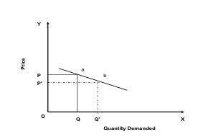

1. 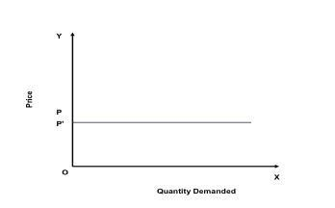Perfectly Elastic Demand (Ed = ∞) a small change in price will change the quantity demanded by an infinite amount.
2. 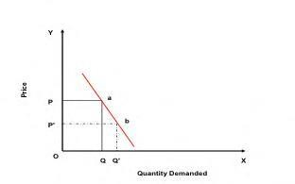Relatively Inelastic Demand (Ed < 1) a change in price leads to a smaller percentage change in quantity demanded.
3. 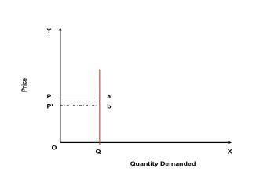Perfectly Inelastic Demand (Ed = 0) the quantity demanded does not change regardless of the percentage change in price.
4. Unit Elasticity of Demand (Ed =1) the percentage change in quantity demanded is the same as the percentage change in price that caused it.

20

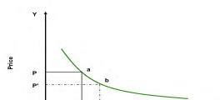

## INCOME ELASTICITY

Income elasticity of demand measures the responsiveness of quantity demanded to a change in income. It is measured by dividing the percentage change in quantity demanded by the percentage change in income. If the demand for a commodity increases by 20% when income increases by 10% then the income elasticity of that commodity is said to be positive and relatively high. If the demand for food were unchanged when income increases, the income elasticity would be zero. A fall in demand for a commodity when income rises results in a negative income elasticity of demand.

The following are the various types of income elasticity:

**Zero Income Elasticity:** The increase in income of the individual does not make any difference in the demand for that commodity. ( Ei = 0)

**Negative Income Elasticity:** The increase in the income of consumers leads to less purchase of those goods. ( Ei < 0).

**Unitary Income Elasticity:** The change in income leads to the same percentage of change in the demand for the good. ( Ei = 1).

**Income Elasticity is Greater than 1:** The change in income increases the demand for that commodity more than the change in the income. ( Ei > 1).

**Income Elasticity is Less than 1:** The change in income increases the demand for the commodity but at a lesser percentage than the change in the Income. ( Ei < 1).

21

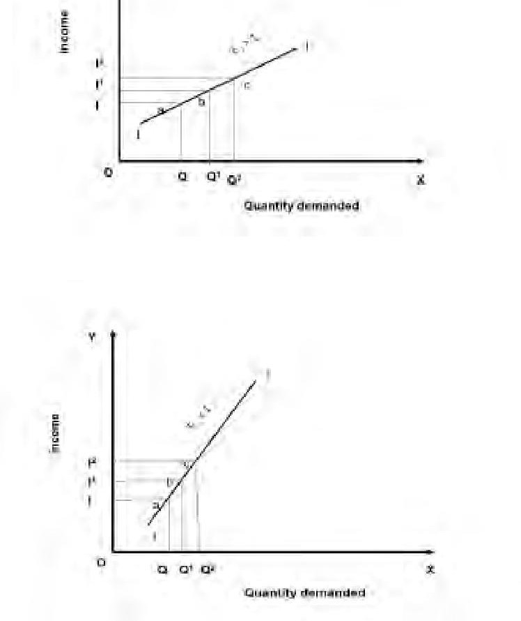

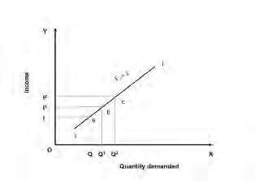The positive income elasticity of demand can be classified as unity, more than unity and less than unity. We can understand from the above graphs that the product which is highly elastic in nature will grow faster when the economy is expanding. The performance of firms having low income elasticity on the other hand will be less affected by the economic changes of the country.

With a rise in consumer’s income, the demand increases for superior goods and decreases for inferior goods and vice versa.

The income elasticity of demand is positive for superior goods or normal goods and negative for inferior goods since a person may shift from inferior to superior goods with a rise in income.

22

## 

## CROSS ELASTICITY

The quantity demanded of a particular commodity varies according to the price of other commodities. Cross elasticity measures the responsiveness of the quantity demanded of a commodity due to changes in the price of another commodity.

For example the demand for tea increases when the price of coffee goes up. Here the cross elasticity of demand for tea is high. If two goods are substitutes then they will have a positive cross elasticity of demand. In other words if two goods are complementary to each other then negative income elasticity may arise.

The responsiveness of the quantity of one commodity demanded to a change in the price of another good is calculated with the following formula.

% change in demand for commodity A Ec

=

% change in price of commodity B

If two commodities are unrelated goods, the increase in the price of one good does not result in any change in the demand for the other goods. For example the price fall in Tata salt does not make any change in the demand for Tata Nano.

## Significance Of Elasticity Of Demand:

The concept of elasticity is useful for the managers for the following decision making activities

1. In production i.e. in deciding the quantity of goods to be produced
2. Price fixation i.e. in fixing the prices not only on the cost basis but also on the basis of prices of related goods.
3. In distribution i.e. to decide as to where, when, and how much etc.
4. In international trade i.e. what to export, where to export
5. In foreign exchange
6. For nationalizing an industry
7. In public finance

## ELEMENTS OF COSTS

Cost can be broadly classfied into variable cost and overhead cost. Variable cost varies with the volume of production while overhead cost is fixed, irrespective of the production volume.

Variable cost can be futher classfied into direct material cost, direct labour cost, and direct expenses. The overhead cost can be classfied into factory overhead, adminstration overhead, selling overhead, and distribution overhead.

Direct material costs are those costs of materials that are used to produce the product. Direct labour cost is the amount of wages paid to the direct labour involved in the production activities. Direct expenses are those expenses that vary in relation to the production volume, other than the direct material costs and direct labour costs.

Overall cost is the aggregate of indirect material costs, indirect labour costs and indirect expenses. Administration overhead includes all the costs that are incurred in administering the business. Selling overhead is the total expense that is incurred in the promotional activities and the expenses relating to sales force. Distribution overhead is the total cost of shipping the items from the factory site to the customer sites

The selling price of a product is derived as shown below:

* 1. Direct material costs + Direct labour costs+ Direct expenses= Prime cost
  2. Prime cost+ Factory overhead = Factory cost.
  3. Factory cost+ office and administrative overhead = cost of production.
  4. cost of production +opening finished stock- Closing finished stock = cost of goods sold.
  5. cost of goods sold + selling and distribution overhead = cost of sales
  6. cost of sales + profit = sales
  7. sales/ Quantity sold = selling price per unit

in the above calculations, if the opening finished stock is equal to the closing finished stock, then the cost of production is equal to the cost of goods sold.

## OTHER COSTS/ REVENUES

The following are the costs/revenue other than the costs which are presented in the previous section:

* + - Marginal cost
    - Marginal revenue
    - Sunk cost
    - Opportunity cost

## Marginal cost:

Marginal cost of a product is the cost of producing an additional unit of that product. Let the cost of producing 20 units of a product be Rs.10,000, and the cost of producing 21 units of the same product be Rs. 10045. Then the marginal cost of producing the 21 units is Rs.45.

## Marginal revenue:

Marginal revenue of a product is the incremental revenue of selling an additional unit of that product. Let the revenue of selling 20 units of a product be Rs.15,000 and the revenue selling 21 units of the same product be Rs.15085. then, the marginal revenue of selling the 21st unit is Rs. 85.

## Sunk Cost:

This is known as the past cost of an equipment/asset. Let us assume that an equipment has been purchased for Rs 1,00,000 about three years back. If it is considered for replacement, then its present value is not Rs. 100000. Instead, its present market value should be taken as the present value of the equipment for further analysis. So, the purchase value of the equipment in the past is known as its sunk cost. The sunk cost should not be considered for any analysis done from nowonwards.

## Opportunity Cost

In practice, if an alternative (X) is selected from a set of competing alternatives(X, Y), then the corresponding investment in the selected alternative is not available for any other purpose. If the same money is invested in some other alternative (Y), it may fetch some return. Since the money is invested in the selected alternative(X), one has to forego the return form the other alternative (Y). The amount that is foregone by not investing in the other alternative(Y) is known as opportunity cost of the selected alternative(X). So the opportunity cost of an alternative is the return that will be foregone by not investing the same money in another alternative.

Consider that a person has invested a sum of Rs 50, 000 in shares. Let the expected annual return by this alternative be rs 7500. If the same amount is invested in fixed deposit, a bank will pay a return of 18%. Then, the corresponding total return per year for the investment in the bank is rs 9000. This return is greater than the return from shares. The foregone excess return of rs 1500 by way of not investing in the bank is the opportunity cost of investing in shares.

## BREAK EVEN ANALYSIS

The main objective of break even analysis is to find the cutt off production volume from where a firm will make profit. Let

, s = selling price per unit

, v = variable cost per unit FC = fixed cost per period Q = volume of production

The total sales revenue (s) of the firm is given by the following formula; S = s x Q

The total cost of the firm for a given production volume is given as

TC = Total variable cost + Fixed cost

= v x Q + FC

The linear plots of the above two equations are shows in below diagram. The intersection point of the total sales revenue line and the total cost line is called the break even point. The corresponding volume of production on the X axis us known as break even sales quantity. At the intersection point, the total cost is equal to the total revenue. This point is also called as no loss or no gain situation. For any production quantity which is less than the break even quantity, the total cost is more than the total revenue. Hence, the firm will be making loss. For any production quantity which is more thatn the break even quantity, the total revenue will be more than the total cost. Hence, the firm will be making profit.

Profit = Sales - (Fixed cost + Variable cost)

= s x Q - (FC + v x Q )

The formulae to find the break even quantity and break even sales quantity



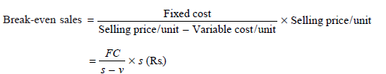

The contribution is the difference between the sales and the variable costs. The margin of safty is the sales over and above the break even sales. The formulae to compute these values are

Contribution = Sales – Variable costs

Contribution /unit = Selling Price/ unit - Variable cost/unit

M. S = Actual Sales – Break even sales



M.S as a per cent of sales = (M.S/ Sales) x 100

***EXAMPLE 1.1*** Alpha Associates has the following details:

Fixed cost = Rs. 20,00,000; Variable cost per unit = Rs. 100; Selling price per unit = Rs. 200 Find

1. The break-even sales quantity,
2. The break-even sales
3. If the actual production quantity is 60,000, find (i) contribution; and

(ii) margin of safety by all methods.

### Solution

Fixed cost (*FC*) = Rs. 20,00,000 Variable cost per unit (*v*) = Rs. 100 Selling price per unit (*s*) = Rs. 200.

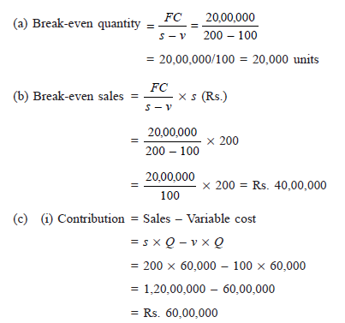

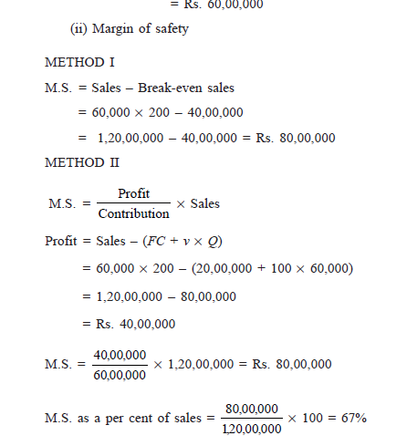

**PROFIT/VOLUME RATIO (*P*/*V* RATIO)**

*P*/*V* ratio is a valid ratio which is useful for further analysis. The different formulae for the *P*/*V*

ratio are as follows:



The relationship between BEP and *P*/*V* ratio is as follows:



The following formula helps us find the M.S. using the *P*/*V* ratio:



***EXAMPLE 1.2*** Consider the following data of a company for the year 1997:

Sales = Rs. 1,20,000 Fixed cost = Rs. 25,000 Variable cost = Rs. 45,000 Find the following:

(a) Contribution (b) Profit (c) BEP (d) M.S.

### Solution

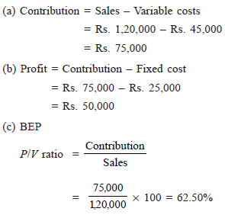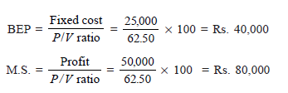

***EXAMPLE 1.3*** Consider the following data of a company for the year 1998: Sales = Rs. 80,000; Fixed cost = Rs. 15,000; Variable cost = 35,000

Find the following:

(a) Contribution (b) Profit (c) BEP (d) M.S. Solution;

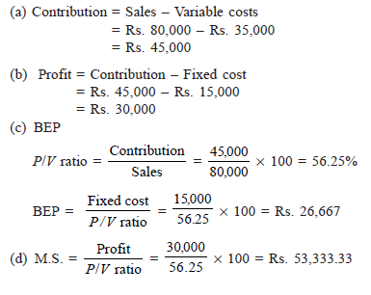

## ISO-Quants:

**Definitions:**

“The Iso-product curves show the different combinations of two resources with which a firm can produce equal amount of product.” Bilas

“Iso-product curve shows the different input combinations that will produce a given output.” Samuelson

“An Iso-quant curve may be defined as a curve showing the possible combinations of two variable factors that can be used to produce the same total product.” Peterson

“An Iso-quant is a curve showing all possible combinations of inputs physically capable of producing a given level of output.” Ferguson

To understand the production function with two variable inputs, iso-quant curve is used. These curves show the various combinations of two variable inputs resulting in the same level of output. The shape of an Iso-quant reflects the ease with which a producer can substitute among inputs while maintaining the same level of output.

From the graph we can understand that the iso-quant curve indicates various combinations of capital and labour usage to produce 100 units of motor pumps. The points a, b or any point in the curve indicates the same quantum of production. If the production increases to

200 or 300 units definitely the input usage will also increase therefore the new iso-quant curve for 200 units (Q1) is shifted upwards. Various iso-quant curves presented in a graph is called as iso- quant map.

**Iso-cost:** different combination of inputs that can be purchased at a given expenditure level.

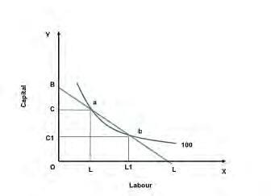

## Optimal input combination:

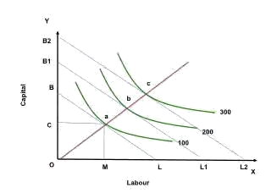

The above graph explains clearly that the iso quant curve for 100 units of motor consists of ‘n’ number of input combinations to produce the same quantity. For example at ‘a’ to produce 100 units of motors the firm uses OC amount of capital and OL amount of labour ie., more capital and less labour force. At ’b’ OC1 amount of capital and OL1 labour force is used to produce the same that means more labour and less capital.

**Optimal input combination:** (the above graph) the points of tangency between iso quant and iso cost curves depict optimal input combination at different activity levels.

**Expansion path:** Optimal input combinations as the scale of production expand. From the graph it is clear that the optimum combination is selected based on the tangency point of iso cost

(budget line) and iso- quant ie., a, b respectively. The point ‘a’ indicates that to produce 100 units of motor the best combination of capital and labour are OC and OM which is within the budget. Over a period of time a firm will face various optimum levels if we connect all points we derive expansion path of a firm.

## The Law of Returns to Scale

In the long run the fixed inputs like machinery, building and other factors will change along with the variable factors like labor, raw material etc. With the equal percentage of increase in input factors various combinations of returns occur in an organization.

**Returns to scale:** the change in percentage output resulting from a percentage change in all the factors of production. They are increasing, constant and diminishing returns to scale.

**Increasing returns to scale may arise:** if the output of a firm increases more than in proportionate to an increase in all inputs. For example the input factors are increased by 50% but the output has doubled (100%).

**Constant returns to scale:** when all inputs are increased by a certain percentage the output increases by the same percentage.

For example input factors are increased by 50% then the output has also increased by 50 percentages. Let us assume that a laptop consists of 50 components we call it as a set. In case the firm purchases 100 sets they can assemble 100 laptops but it is not possible to produce more than 100 units.

**Diminishing returns to scale:** when output increases in a smaller proportion than the increase in inputs it is known as diminishing return to scale. For example 50% increment in input factors lead to only 20% increment in the output.

## Managerial Uses Of Production Function:

Production functions are logical and useful. Production analysis can be used as aids in decision making because they can give guidance to obtain the maximum output from a given set of inputs and how to obtain a given output from the minimum aggregation of inputs. The complex production functions with large numbers of inputs and outputs are analyzed with the help of computer based programmes.

## MONEY;

Money is any good that is widely accepted in exchange of goods and services, as well as payment of debts.

## FUNCTIONS OF MONEY;

1. **Medium of exchange**: Money can be used for buying and selling goods and services. If there were no money, goods would have to be exchanged through the process of barter (goods would be traded for other goods in transactions arranged on the basis of mutual need). For example: If I raise chickens and want to buy cows, I would have to find a person who is willing to sell his cows for my chickens. Such arrangements are often difficult. But Money eliminates the need of the double coincidence of wants.
2. **Unit of account**: Money is the common standard for measuring relative worth of goods and service.
3. **Store of value**: Money is the most liquid asset (Liquidity measures how easily assets can be spent to buy goods and services). Money’s value can be retained over time. It is a convenient way to store wealth.

## NATIONAL INCOME;

National income is the total value a country’s final output of all new goods and services produced in one year.

There are a number of concepts pertaining to national income and methods of measurement relating to them.

## Gross Domestic Product (GDP):

GDP is the total value of goods and services produced within the country during a year. This is calculated at market prices and is known as GDP at market prices. Dernberg defines GDP at market price as “the market value of the output of final goods and services produced in the domestic territory of a country during an accounting year.”

## GDP at Factor Cost:

GDP at factor cost is the sum of net value added by all producers within the country. Since the net value added gets distributed as income to the owners of factors of production, GDP is the sum of domestic factor incomes and fixed capital consumption (or depreciation).

Thus GDP at Factor Cost = Net value added + Depreciation.

**GDP at factor cost includes:**

1. Compensation of employees i.e., wages, salaries, etc.
2. Operating surplus which is the business profit of both incorporated and unincorporated firms. [Operating Surplus = Gross Value Added at Factor Cost—Compensation of Employees— Depreciation]
3. Mixed Income of Self- employed.

## Net Domestic Product (NDP):

NDP is the value of net output of the economy during the year. Some of the country’s capital equipment wears out or becomes obsolete each year during the production process. The value of this capital consumption is some percentage of gross investment which is deducted from GDP. Thus Net Domestic Product = GDP at Factor Cost – Depreciation.

## Gross National Product (GNP):

GNP is the total measure of the flow of goods and services at market value resulting from current production during a year in a country, including net income from abroad.

**GNP includes four types of final goods and services:**

1. Consumers’ goods and services to satisfy the immediate wants of the people;
2. Gross private domestic investment in capital goods consisting of fixed capital formation, residential construction and inventories of finished and unfinished goods;
3. Goods and services produced by the government; and
4. Net exports of goods and services, i.e., the difference between value of exports and imports of goods and services, known as net income from abroad.

**INFLATION;**

**Inflation** is the rate at which the general level of prices for goods and services is rising and, consequently, the purchasing power of currency is falling.

**DEFLATION;**

**Deflation** is a decrease in the general price level of goods and services

# Management:

Harold Koontz defined Management as “Management is the art of getting work done out of others, working in group’.

Henry Fayol defined Management as” To manage is to forecast and plan, to organize, to command, to co-ordinate to control.

According to James Moony Management is art of directing and inspiring people.

Management is an art of making people work in an effective and efficient manner. Effectiveness is the ability to choose appropriate goal and achieve them.

Efficiency is ability to make the best use of the available resources in the process of achieving goals

# Nature and Characteristics or features or Elements of Management:

* Management is an activity

A manager performs a managerial activity. The managerial activity is, in fact the managerial job i.e the task performed by a manager or the group of managers is an enterprises. Planning, organizing, staffing, directing and controlling are the some of the activities of managers.

* Management is a universal Process

The process of management can be noticed in all spheres of life. The basic characterstics of management activity are the same in all type of organization. The management activity is basically the same everywhere.

* Management is factor of production

Since its control the productions main concepts Men, Money, Machine, Materials and Methods, it is considered as factor of production.

* Management is intangible (indefinable)

Management has been called as unseen force, its presence in evidenced by the results of its efforts. Thus the feeling of management is result oriented

* Management is purposeful

Management deals with the achievement of something. Commonly managerial success is measured by the extent to which the objectives are achieved.

* Decision Making

Management process involves decision making that is it involves the evaluation and selection of alternatives

**HENRY FAYOL’S CONTRIBUTIONTO MANAGEMENT:**

# a. Introduction to fayol and his work

Henry Fayol (1841-1925) was a French mining who turned a leading industrialist and successful manager. He was a mining engineer in a French mining and rose to the position of the chief managing director.

Fayol’s classification of business functions;

* + **Technical activities** (relating to production)
  + **Commercial activities (**relating to buying, selling or exchange**)**
  + **Financial activities (**relating to search for and optimum use of capital i.e. finances**)**
  + **Security activities** (relating to production of the properties and personnel of the enterprise**)**
  + **Accounting activities (**relating to a systematic recording of business transactions, including statistics also)

# General principle of management:

**Fayol advocated fourteen principles of management.**

1. **Division of work: division of work- leading to specialization- result in increased** human efficiency; as through the application of this principle, much more production is possible with the same amount of human efforts. **It** results in efficient use of resources and increases productivity. This is applicable to both managerial and technical functions.
2. **Authority and responsibility**: it is the power inherent in a managerial position which enables a manager to command subordinates to work towards the attainment of enterprise objectives. Responsibility, is the reverse of authority; whose essence is an obligation owed by a subordinate

to the superior for the proper performance of the job for which authority is granted to the former.

1. **Discipline:** discipline is absolutely necessary for the smooth running of an organization. Discipline means following rules, regulations, policies and procedures by all employee of organization.
2. **Unity of command:** an employee should receive orders from one supervisor only to avoid possible confusion and conflict. This principle is useful in the clarification of authority.
3. **Unity of direction:** all the activities must be aimed at one common objective. It implies that for each group of activities having the same objective. There must be’ one head and one plan’.
4. **Subordinate of individual interest to general interest**: the interest of one employee or group should not be given importance over the interest and goals of an organization.
5. **Remuneration of personnel**: remuneration of personnel is the price paid or payable to people – managers and workers- for their service rendered towards the attainment of the enterprise objectives.
6. **Centralization authority**: it refers to refers to reservation of decision- making authority at top levels of management. Decentralization, on the other hand, means – a dispersal of authority from the central (top –level) points to middle, and specially lower level of management.
7. **Scalar chain:** management may be regarded as a *chain of superiors. There* should be an unbroken line of authority and command through all levels from the highest (i.e. general manager) to the lowest ranks (employee).
8. **Order:** this promotes the idea that everything (e.g. materials) and everyone (human being) has his place in the organization.

Materials and human beings should be arranged such that right material (think)/person is in the right place.

1. **Equity of treatment**: Manager should have fairness in treatment for all his subordinates.

-Manager should deal with his subordinate with kindness and justice.

- This will make employee more loyal and devoted towards the management.

# Stability:

-stable and secure work force is an asset to the enterprise, because unnecessary labour turnovers are costly.

* An average employee who stays with the concern is much better than outstanding employees who merely come and go.
* Instability is the result of bad management.

# Initiative:

Manager should sacrifice their personal vanity in order to permit their subordinates to exercise their own initiative. A manager should encourage his subordinate to take initiative.

# Esprit de crops:

- This principle of management emphasizes the need for teamwork (harmony, and proper understanding) among the employee and shows the importance of communication in obtaining such team work.

* It is unity of strength

# FUNCTIONS OF MANAGEMENT

* 1. **Planning:**

 Planning involves the formulation of what is to be done, how when and where it is to be done, who is to do it and what result are to be evaluated.

 Planning means looking ahead, it is mental work, it is selecting from among many choices following the procedure given below:

* Lay down the company objective/ targets
* Collect and classify the information relating to company objectives.
* Develop alternative course of action to do the things.
* Compare the alternative in terms of objectives, feasibility and consequences.
* Select the optimum course of action yielding maximum benefit/gain.
* Establish policies, procedure, methods, schedules, programmes, system, standards, and budgets for the optimum course of action selected.

# Organizing:

1. After determining the course and make-up of action. The next step, in order to accomplish the task, is to distribute the necessary work among the working groups.
   * It is the process of by which the structure and allocation of jobs is determined.
   * It means organizing people materials, jobs, time, etc., and establishing framework in which responsibilities are defined and authorities and laid down
2. The process of organizing involves:
   * Divide the work into component activities
   * Assign people to task (component activities)
   * Define responsibilities
   * Delegate authority
   * Establish structural relationship (i.e. organization structure) to secure coordination.

# Staffing :

* + - Staffing is the process by which managers select, train, promote and retire their subordinates.
    - Staffing involves the developing and placing of qualified people in the various jobs in the organizations
    - Staffing is a continuous process. The aim is to have appropriate persons to move into vacated positions newly created in the enterprise.
    - Function of staffing is from **Recruitment** to **Retirement** (RR)

# Directing :

* Directing is the process by which actual performance of subordinates is guided towards common goals of the enterprise
* It includes
  + Giving instructions to subordinates
  + Guiding the subordinates to do the work
  + Supervising the subordinates to make certain that the work done by them is as per the plan established.
* Directing involves functions such as

1. **Leadership:** leadership is the quality of the behavior of the persons (managers) whereby they inspire confidence and trust in their subordinates, get maximum cooperation from them and guide their activities in organized effort.
2. **Communication:** it is the process by which ideas are transmitted, received and understood by others for the purpose of effecting desired results.
3. **Motivation:** motivation means inspiring the subordinates to do work or to achieve company objective effectively and efficiently.
4. **Supervision: supervision** is necessary in order to ensure I. that the work is going on as per plan established, and II that the workers are doing as they were directed to do.

# Controlling :

 Controlling is the process that measures current performance and guide it towards some predetermined goal.

 Controlling means checking up to ensure that the planned work is progressing as per schedule and if not, then to apply corrective action to achieve the pre-determined objectives.

 The process of controlling involves:-

1. Observe continuously and study the periodic results of performance
2. Compare this performance with the present standards
3. pinpoint deviations if any
4. Ascertain the extract causes of deviations
5. Initiate and implement the corrective action.

**FIRM;**

A firm is a business organization, such as a corporation, limited liability company or partnership, that sells goods or services to make a profit.